**[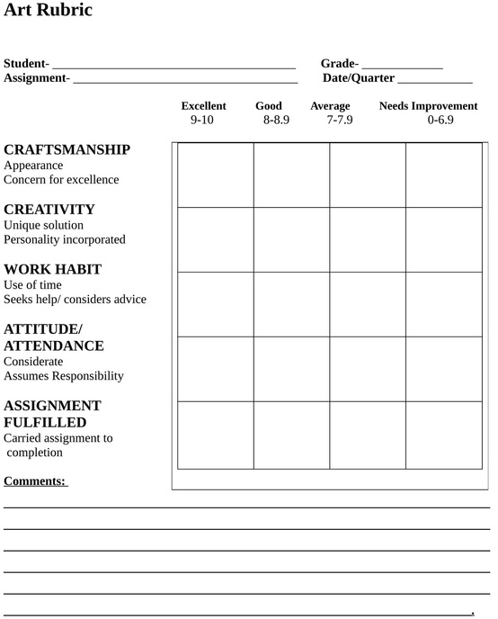](http://www.google.ca/imgres?hl=en&biw=1366&bih=600&tbm=isch&tbnid=DJw2aPC6-vcxuM:&imgrefurl=http://michaelrcarter.blogspot.com/2011/04/curriculum-rubrics-and-things-people.html&docid=-iwgB4mMcDIilM&imgurl=http://3.bp.blogspot.com/-0YpqjBrjbao/TZUdKIi7h1I/AAAAAAAAA-k/Gf26Fr5e1nM/s1600/My%2BArt%2BRubric%2B.jpg&w=1288&h=1600&ei=p_N0UIanHMWIiwLb1ICQAQ&zoom=1&iact=hc&vpx=680&vpy=120&dur=2943&hovh=250&hovw=201&tx=82&ty=154&sig=107237179192847496110&page=1&tbnh=131&tbnw=105&start=0&ndsp=23&ved=1t:429,r:4,s:0,i:80)**