**Ceramic Projects for the Trimester**

**(Your grade will reflect how you use your time, and how many of these projects you complete during the allotted time. You have the whole trimester to finish all 10 of these projects.)**

**Project 1& 2:** Using the pinch pot technique, create a set of Nature vessel or dishes. Create a minimum of 2. There is a wide range of Nature inspired ideas, such as: Flowers, Trees, and Animals etc.

[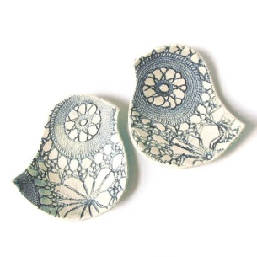](http://img2.etsystatic.com/il_fullxfull.227608078.jpg)[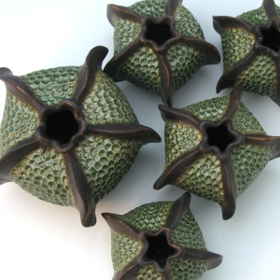](http://img2.etsystatic.com/il_fullxfull.303785622.jpg)[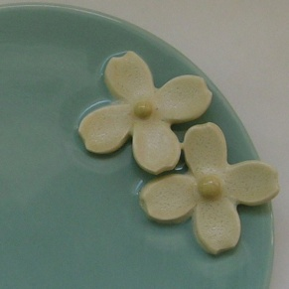](http://img2.etsystatic.com/il_fullxfull.163874614.jpg)[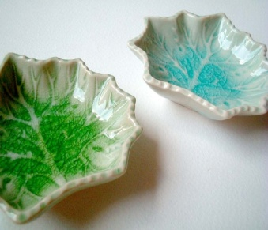](http://img0.etsystatic.com/il_fullxfull.240112172.jpg)[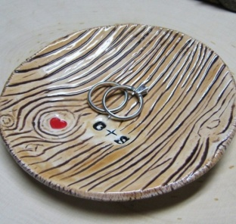](http://img0.etsystatic.com/il_fullxfull.147502652.jpg)

**Project 3:** Using coiling techniques create a Braided/Coiled Vessel. I encourage creativity with your coils, they do NOT need to look the same, add some of your own personality in the vessel. [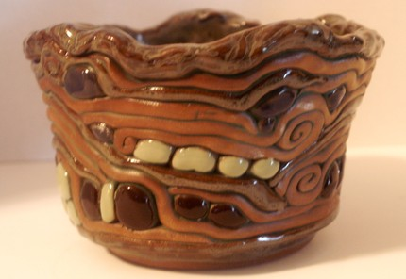](http://ny-image1.etsy.com/il_fullxfull.92870081.jpg)[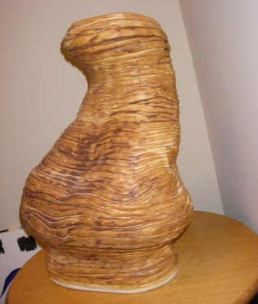](http://ny-image3.etsy.com/il_fullxfull.66717551.jpg)[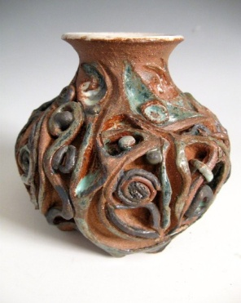](http://ny-image0.etsy.com/il_fullxfull.108383152.jpg)[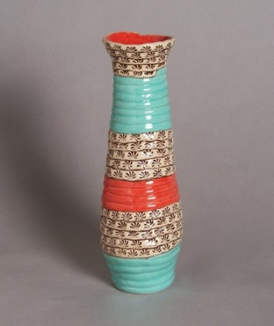](http://ny-image2.etsy.com/il_fullxfull.124728586.jpg)[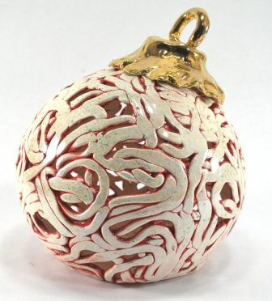](http://img2.etsystatic.com/il_fullxfull.293588594.jpg)

**Project 4:** Soft Slab/Hard Slab**-** Using slabs create individual tiles with a unity theme. Use texture and carving to tell the viewer what they are with pictures, words, textures, etc... Put emotion into it.

[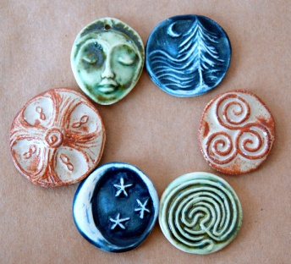](http://img0.etsystatic.com/il_fullxfull.315221624.jpg)**[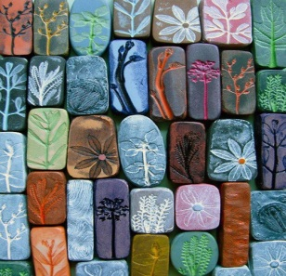](http://homedesignspins.com/?p=39361)**[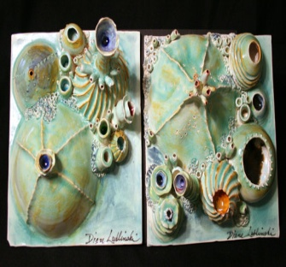](http://img1.etsystatic.com/il_fullxfull.264078141.jpg)[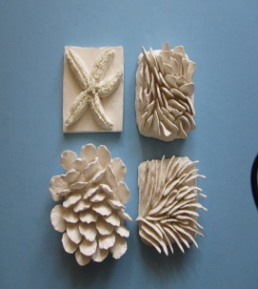](http://img3.etsystatic.com/il_fullxfull.241871103.jpg)[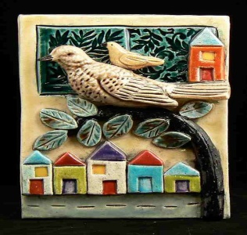](http://img0.etsystatic.com/il_fullxfull.284119776.jpg)

**Project 5:** Slab Pockets- Using two slabs to create a pocket, joining together, and adding some form of embellishment. You may either incise or emboss on the front pocket.

[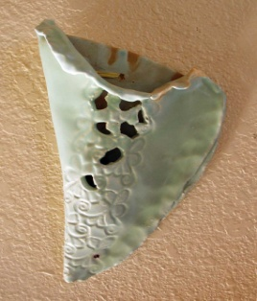](http://img2.etsystatic.com/il_fullxfull.285513950.jpg)[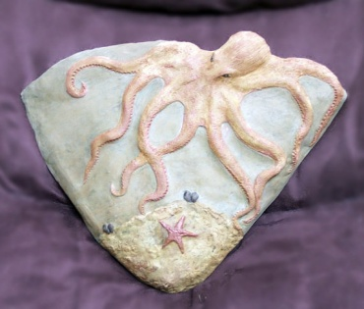](http://img3.etsystatic.com/il_fullxfull.308043619.jpg)[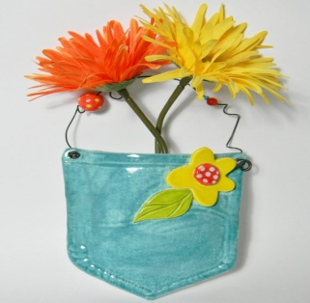](http://img3.etsystatic.com/il_fullxfull.314170763.jpg)[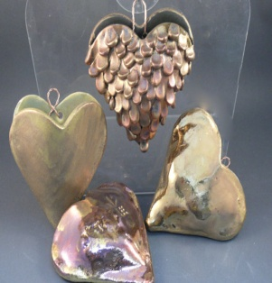](http://img1.etsystatic.com/il_fullxfull.267652925.jpg)[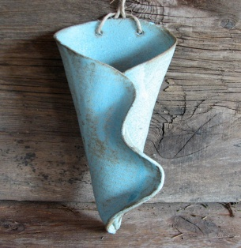](http://img1.etsystatic.com/il_fullxfull.283437653.jpg)

**Project 6:** Free Form Bowl- Rolling out slabs of clay, cutting in the shape of a circle, and allowing the bowl to shape itself after resting inside another bigger bowl.

**[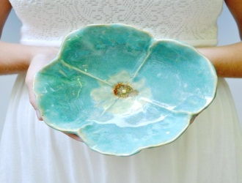](http://www.etsy.com/listing/59789337/pottery-bowl-poppy-bowl-ceramic-soup)**[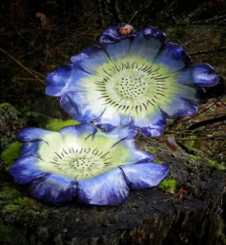](http://img1.etsystatic.com/il_fullxfull.226059473.jpg)[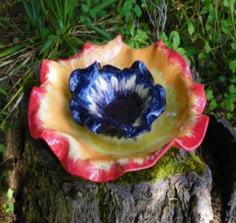](http://img3.etsystatic.com/il_fullxfull.240350959.jpg)**[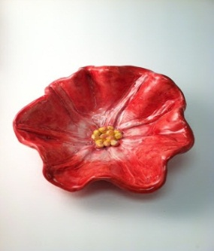](http://www.thecrayonlab.com/2012/11/georgia-okeeffe-flower-bowls.html)**[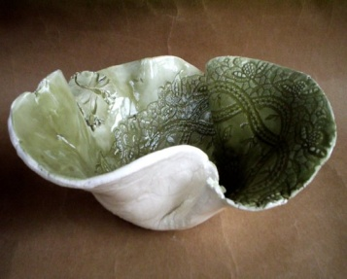](http://img0.etsystatic.com/il_fullxfull.133928048.jpg)

**Project 7:** Wheel Throwing- Using the basics of wheel throwing create 2 bowls or vessels, using basic centering, pulling, and foot carving.

[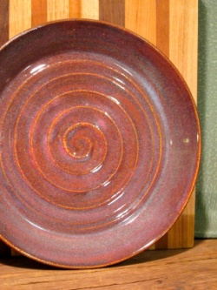](http://img3.etsystatic.com/il_fullxfull.292283851.jpg)[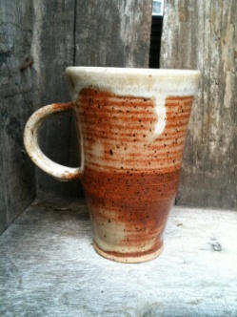](http://img2.etsystatic.com/il_fullxfull.299194678.jpg)[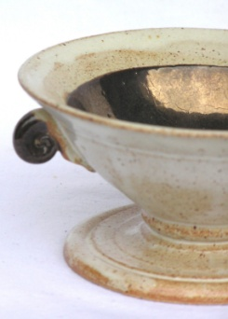](http://img0.etsystatic.com/il_fullxfull.9376284.jpg)[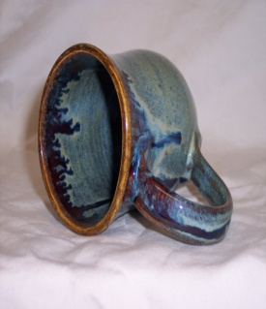](http://img3.etsystatic.com/il_fullxfull.298423015.jpg)[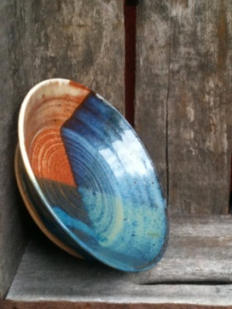](http://img2.etsystatic.com/il_fullxfull.298186850.jpg)[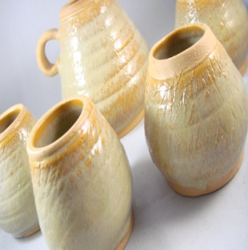](http://img0.etsystatic.com/il_fullxfull.291023456.jpg)

**Project 8:** MINITATURE Village or city- Design a village, town, or city. You must have at least 10 buildings or houses. The more details you add to your buildings, the better your village will look.

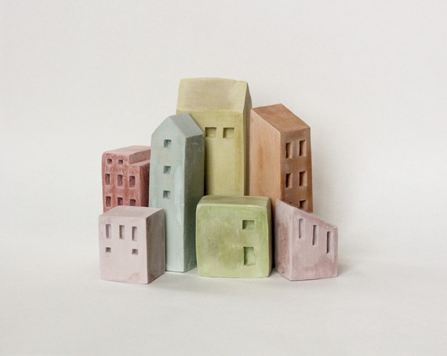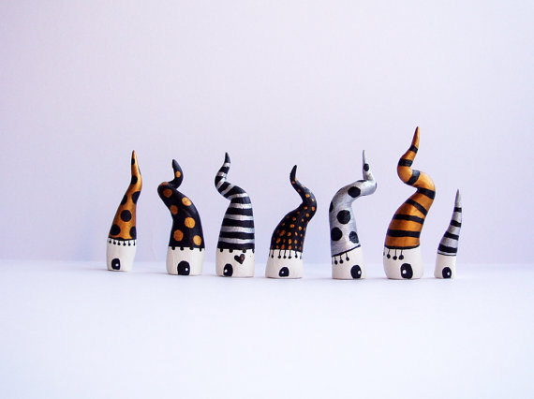**[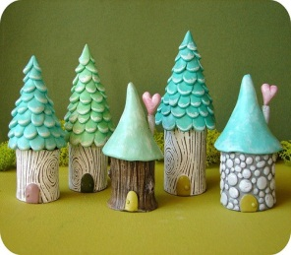](http://french-knot.tumblr.com/page/108)**[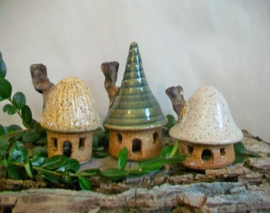](http://img2.etsystatic.com/il_fullxfull.296605162.jpg)**[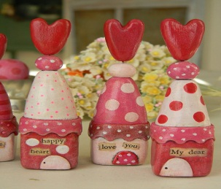](http://noodleandlou.blogspot.com/search?q=valentine)**

**Project 9:** REPRESENTATION OF FOOD- Create at least 3 pieces of your favorite foods. Each piece should not exceed over 3 inches, and they should all look as realistic as possible.

[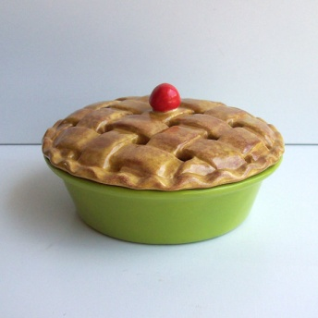](http://img1.etsystatic.com/il_fullxfull.256469365.jpg)[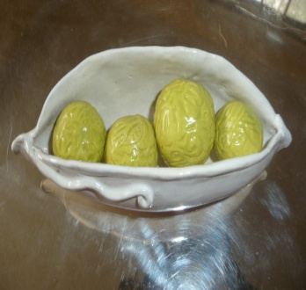](http://img0.etsystatic.com/il_fullxfull.307159700.jpg)[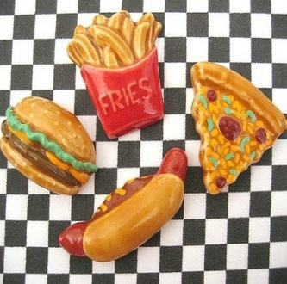](http://img0.etsystatic.com/il_fullxfull.280759900.jpg)[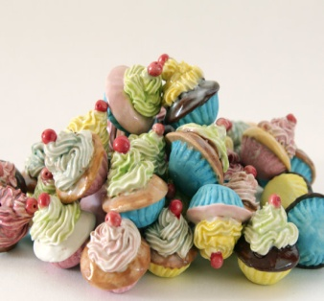](http://img3.etsystatic.com/il_fullxfull.300859587.jpg)[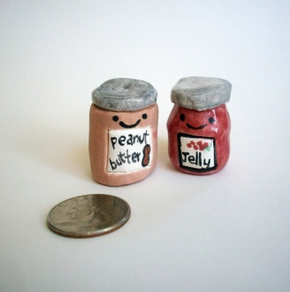](http://img3.etsystatic.com/il_fullxfull.303410839.jpg)

**Project 10**: PROJECT OF YOUR CHOICE. Explore a creative idea/project that you are interested in, there are endless possibilities. For this project you must have multiple pieces, and get it approved by Ms. Powers

**[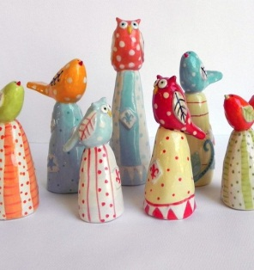](http://www.etsy.com/listing/68748092/family-of-3-owls)[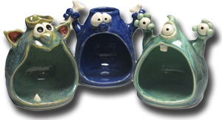](http://www.claymonster.net/)[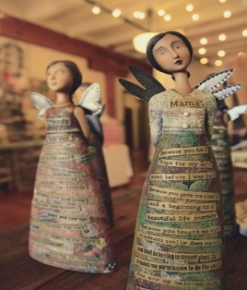](http://kellyraeroberts.blogspot.com/2012/03/finally-showroom-tour-of-new-goodies.html)[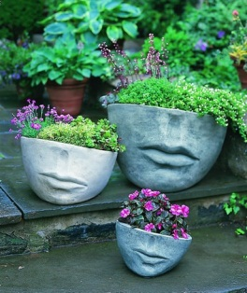](http://campaniainternational.com/index.php?page=faccia-large-planter)[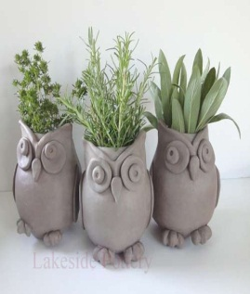](http://www.lakesidepottery.com/Pages/Pictures/Handbuilding-projects-ideas-pictures.html)[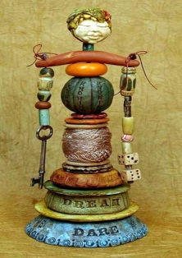](http://www.weefolk.com/brochuremoldb2_samples.htm)**